Program:1

Aim:Define a class ‘product’ with data members pcode, pname and price. Create 3 objects of
the class and find the product having the lowest price.

Source Code:

public class Product {
String pname, pcode;
int price;

public String getPname(){
return pname;
}
public Product(){
}

public Product(String pname,String pcode, int price){
this.pname=pname;
this.pcode=pcode;
this.price=price;
}
public void setPname(String pname){
this.pname=pname;}
public String getPcode(){
return pcode;}

public void setPcode(String pcode){
this.pcode=pcode;

}
public int getPrice(){
return price;}

public void setPrice(int Price){
this.price=price;}

public void display(){

System.out.println("pcode:"+ this.pcode);
System.out.println("pname:"+ this.pname);
System.out.println("price:"+ this.price);
}

public static void main(String[] args){
Product p1=new Product();
p1.pcode="Car123";
p1.pname="Benz";
p1.price=10000;
System.out.println("Thasni Noufal\n57\n13-02-2024\nprgm1 Define a class ‘product’ with data members pcode, pname and price. Create 3 objects ofthe class and find the product having the lowest price.");

System.out.println("*****Displaying_p1*********");
p1.display();

Product p2=new Product("jaguar","Car426",25000);
System.out.println("\n***********Displaying_p2***********");
p2.display();

Product p3=new Product("Maruthi","Car800",50000);
System.out.println("\n***********Displaying_p3***********");
p3.display();

Product p=p3.getPrice()<(p1.price<p2.price? p1.price:p2.price)?
p3:(p1.price <p2.price? p1:p2);
System.out.println("\n*********Displaying_product_with_lowest_price******");
p.display();
}

}

Output:

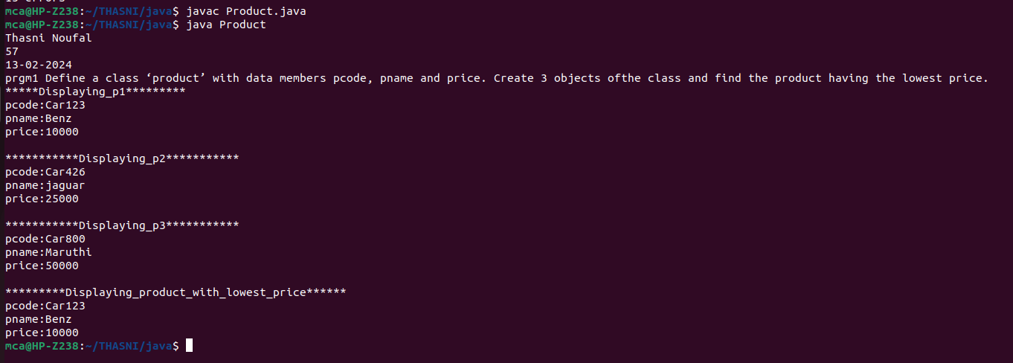

Program:5

Aim:program to Sort String

public class SortString{
public static void main(String[] args)
{
String names[]={"st","joseph","college","of","engeneering"};
String temp;
int n=names.length;
int i;
int j;
for(i=0;i<n;i++)
{
for(j=i+1;j<n;j++)
{
if(names[i].compareTo(names[j])>0)
{
temp=names[i];
names[i]=names[j];
names[j]=temp;
}
}
}
System.out.println("the stored array of string is:");
System.out.println("Thasni Noufal,Roll No:57,26-02-2024");
for(i=0;i<n;i++)
{
System.out.println(names[i]);
}
}
}

